Лабораторная работа № 21
Тема: Основные идеи технологии в WPF.
По дисциплине: Разработка программных модулей

Выполнил:
Овчиников Никита ИС24
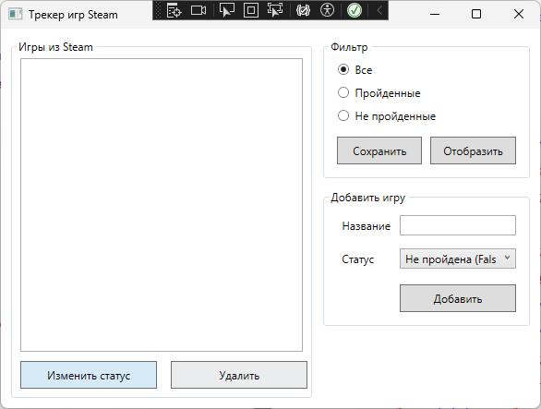

Как выглядит приложение

MainWindow.xaml:

<Window x:Class="SteamGamesTracker.MainWindow"
xmlns="http://schemas.microsoft.com/winfx/2006/xaml/presentation"
xmlns:x="http://schemas.microsoft.com/winfx/2006/xaml"
Title="Трекер игр Steam" Height="450" Width="600"
WindowStartupLocation="CenterScreen">
<Grid Margin="10">
<Grid.ColumnDefinitions>
<ColumnDefinition Width="3*"/>
<ColumnDefinition Width="2*"/>
</Grid.ColumnDefinitions>

<GroupBox Header="Игры из Steam" Grid.Column="0" Margin="0,0,10,0">
<Grid>
<Grid.RowDefinitions>
<RowDefinition Height="*"/>
<RowDefinition Height="Auto"/>
</Grid.RowDefinitions>

<ListBox x:Name="GamesList" Grid.Row="0" Margin="5"
HorizontalContentAlignment="Stretch"
SelectionMode="Single">
<ListBox.ItemTemplate>
<DataTemplate>
<Border BorderBrush="#87CEFA" BorderThickness="1" CornerRadius="4" Margin="0,3">
<Grid Margin="5">
<Grid.ColumnDefinitions>
<ColumnDefinition Width="*"/>
<ColumnDefinition Width="120"/>
</Grid.ColumnDefinitions>
<TextBlock Text="{Binding Name}" FontWeight="Bold" VerticalAlignment="Center"/>
<Rectangle Grid.Column="1" Fill="{Binding StatusColor}" Height="20" RadiusX="2" RadiusY="2"/>
</Grid>
</Border>
</DataTemplate>
</ListBox.ItemTemplate>
</ListBox>

<Grid Grid.Row="1" Margin="5">
<Grid.ColumnDefinitions>
<ColumnDefinition Width="*"/>
<ColumnDefinition Width="*"/>
</Grid.ColumnDefinitions>
<Button Content="Изменить статус" Background="#D6EAF8" Margin="0,0,5,0" Height="30" Click="BtnChangeStatus_Click"/>
<Button Content="Удалить" Background="#EAECEE" Margin="5,0,0,0" Height="30" Click="BtnDelete_Click"/>
</Grid>
</Grid>
</GroupBox>

<Grid Grid.Column="1">
<Grid.RowDefinitions>
<RowDefinition Height="Auto"/>
<RowDefinition Height="Auto"/>
<RowDefinition Height="*"/>
</Grid.RowDefinitions>

<GroupBox Header="Фильтр" Grid.Row="0" Margin="0,0,0,10">
<StackPanel Margin="10">
<RadioButton x:Name="RbAll" Content="Все" IsChecked="True" Margin="0,0,0,10"/>
<RadioButton x:Name="RbCompleted" Content="Пройденные" Margin="0,0,0,10"/>
<RadioButton x:Name="RbNotCompleted" Content="Не пройденные" Margin="0,0,0,15"/>

<Grid>
<Grid.ColumnDefinitions>
<ColumnDefinition Width="*"/>
<ColumnDefinition Width="*"/>
</Grid.ColumnDefinitions>
<Button Content="Сохранить" Margin="0,0,5,0" Height="30" Click="BtnSave_Click"/>
<Button Content="Отобразить" Margin="5,0,0,0" Height="30" Click="BtnFilter_Click"/>
</Grid>
</StackPanel>
</GroupBox>

<GroupBox Header="Добавить игру" Grid.Row="1">
<Grid Margin="10">
<Grid.RowDefinitions>
<RowDefinition Height="Auto"/>
<RowDefinition Height="Auto"/>
<RowDefinition Height="Auto"/>
</Grid.RowDefinitions>
<Grid.ColumnDefinitions>
<ColumnDefinition Width="Auto"/>
<ColumnDefinition Width="*"/>
</Grid.ColumnDefinitions>

<Label Content="Название" Grid.Row="0" Grid.Column="0" Margin="0,0,5,10"/>
<TextBox x:Name="TxtGameName" Grid.Row="0" Grid.Column="1" Height="22" Margin="0,0,0,10"/>

<Label Content="Статус" Grid.Row="1" Grid.Column="0" Margin="0,0,5,15"/>
<ComboBox x:Name="CmbStatus" Grid.Row="1" Grid.Column="1" Height="22" Margin="0,0,0,15" SelectedIndex="0">
<ComboBoxItem Content="Не пройдена (False)"/>
<ComboBoxItem Content="Пройдена (True)"/>
</ComboBox>

<Button Content="Добавить" Grid.Row="2" Grid.Column="1" Height="30" Click="BtnAdd_Click"/>
</Grid>
</GroupBox>
</Grid>
</Grid>
</Window>

App.xaml.cs:

using System;
using System.Collections.Generic;
using System.Configuration;
using System.Data;
using System.Linq;
using System.Threading.Tasks;
using System.Windows;

namespace SteamGamesTracker
{
/// <summary>
/// Логика взаимодействия для App.xaml
/// </summary>
public partial class App : Application
{
}
}

MainWindow.xaml.cs:
using System;
using System.Collections.Generic;
using System.Collections.ObjectModel;
using System.ComponentModel;
using System.IO;
using System.Linq;
using System.Text;
using System.Threading.Tasks;
using System.Windows;
using System.Windows.Controls;
using System.Windows.Data;
using System.Windows.Documents;
using System.Windows.Input;
using System.Windows.Media;
using System.Windows.Media.Imaging;
using System.Windows.Navigation;
using System.Windows.Shapes;

namespace SteamGamesTracker
{
/// <summary>
/// Логика взаимодействия для MainWindow.xaml
/// </summary>
public partial class MainWindow : Window
{

private ObservableCollection<GameItem> _allGames;
private readonly string _saveFilePath = "games_data.txt";

public MainWindow()
{
InitializeComponent();
_allGames = new ObservableCollection<GameItem>();
LoadData();
ApplyFilter();
}

private void BtnAdd_Click(object sender, RoutedEventArgs e)
{
string name = TxtGameName.Text.Trim();
if (string.IsNullOrEmpty(name))
{
MessageBox.Show("Введите название игры!", "Ошибка", MessageBoxButton.OK, MessageBoxImage.Warning);
return;
}

bool isCompleted = CmbStatus.SelectedIndex == 1;

_allGames.Add(new GameItem { Name = name, IsCompleted = isCompleted });

TxtGameName.Clear();
CmbStatus.SelectedIndex = 0;
ApplyFilter();
}

private void BtnDelete_Click(object sender, RoutedEventArgs e)
{
if (GamesList.SelectedItem is GameItem selectedGame)
{
_allGames.Remove(selectedGame);
ApplyFilter();
}
else
{
MessageBox.Show("Выберите игру для удаления.", "Внимание", MessageBoxButton.OK, MessageBoxImage.Information);
}
}

private void BtnChangeStatus_Click(object sender, RoutedEventArgs e)
{
if (GamesList.SelectedItem is GameItem selectedGame)
{
selectedGame.IsCompleted = !selectedGame.IsCompleted;
ApplyFilter();
}
else
{
MessageBox.Show("Выберите игру для изменения статуса.", "Внимание", MessageBoxButton.OK, MessageBoxImage.Information);
}
}

private void BtnFilter_Click(object sender, RoutedEventArgs e)
{
ApplyFilter();
}

private void BtnSave_Click(object sender, RoutedEventArgs e)
{
try
{
var lines = _allGames.Select(g => $"{g.Name}|{g.IsCompleted}");
File.WriteAllLines(_saveFilePath, lines);
MessageBox.Show("Данные успешно сохранены!", "Сохранение", MessageBoxButton.OK, MessageBoxImage.Information);
}
catch (Exception ex)
{
MessageBox.Show($"Ошибка при сохранении: {ex.Message}", "Ошибка", MessageBoxButton.OK, MessageBoxImage.Error);
}
}

private void ApplyFilter()
{
if (RbCompleted.IsChecked == true)
{
GamesList.ItemsSource = new ObservableCollection<GameItem>(_allGames.Where(g => g.IsCompleted));
}
else if (RbNotCompleted.IsChecked == true)
{
GamesList.ItemsSource = new ObservableCollection<GameItem>(_allGames.Where(g => !g.IsCompleted));
}
else
{
GamesList.ItemsSource = _allGames;
}
}

private void LoadData()
{
if (File.Exists(_saveFilePath))
{
try
{
string[] lines = File.ReadAllLines(_saveFilePath);
foreach (var line in lines)
{
var parts = line.Split('|');
if (parts.Length == 2 && bool.TryParse(parts[1], out bool isCompleted))
{
_allGames.Add(new GameItem { Name = parts[0], IsCompleted = isCompleted });
}
}
}
catch (Exception ex)
{
MessageBox.Show($"Ошибка при загрузке: {ex.Message}", "Ошибка", MessageBoxButton.OK, MessageBoxImage.Error);
}
}
}
}

public class GameItem : INotifyPropertyChanged
{
private string _name;
private bool _isCompleted;

public string Name
{
get => _name;
set { _name = value; OnPropertyChanged(nameof(Name)); }
}

public bool IsCompleted
{
get => _isCompleted;
set
{
_isCompleted = value;
OnPropertyChanged(nameof(IsCompleted));
OnPropertyChanged(nameof(StatusColor));
}
}
public Brush StatusColor => IsCompleted ? Brushes.ForestGreen : Brushes.Red;

public event PropertyChangedEventHandler PropertyChanged;
protected void OnPropertyChanged(string propertyName)
{
PropertyChanged?.Invoke(this, new PropertyChangedEventArgs(propertyName));
}
}
}

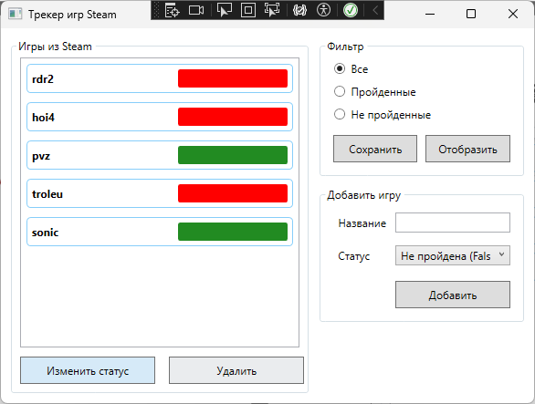
Приложение:

Изменение статусов предметов:
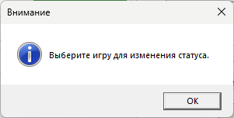
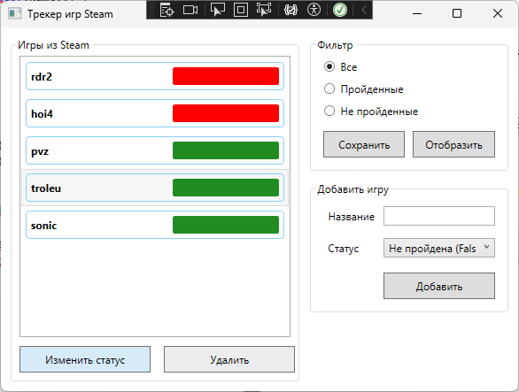

Удаление предметов:
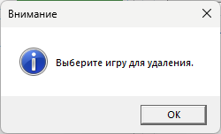
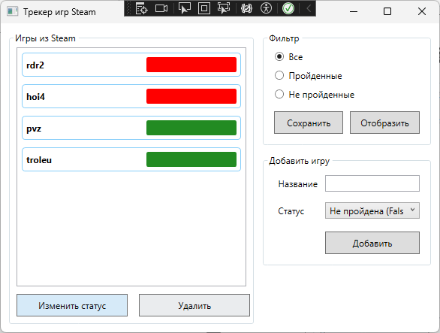

Работа фильтра:

